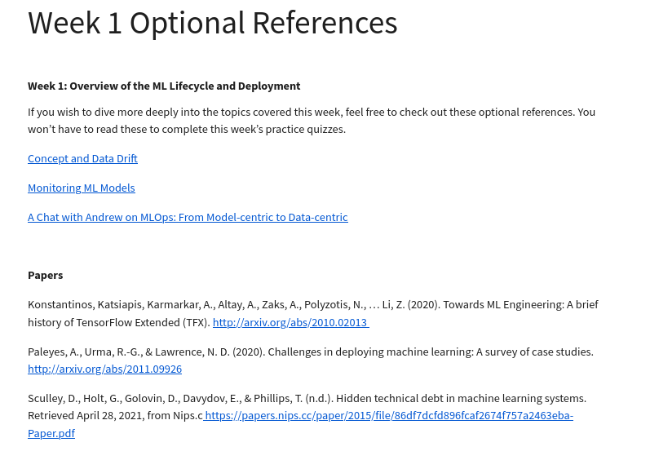

<https://towardsdatascience.com/machine-learning-in-production-why-you-should-care-about-data-and-concept-drift-d96d0bc907fb>

[https://christophergs.com/machine%20learning/2020/03/14/how-to-monitor-machine-learning-models/](https://christophergs.com/machine learning/2020/03/14/how-to-monitor-machine-learning-models/)

<https://www.youtube.com/watch?v=06-AZXmwHjo>

Papers

Konstantinos, Katsiapis, Karmarkar, A., Altay, A., Zaks, A., Polyzotis, N., … Li, Z. (2020). Towards ML Engineering: A brief history of TensorFlow Extended (TFX). <http://arxiv.org/abs/2010.02013>

Paleyes, A., Urma, R.-G., & Lawrence, N. D. (2020). Challenges in deploying machine learning: A survey of case studies. <http://arxiv.org/abs/2011.09926>

Sculley, D., Holt, G., Golovin, D., Davydov, E., & Phillips, T. (n.d.). Hidden technical debt in machine learning systems. Retrieved April 28, 2021, from Nips.c<https://papers.nips.cc/paper/2015/file/86df7dcfd896fcaf2674f757a2463eba-Paper.pdf>